

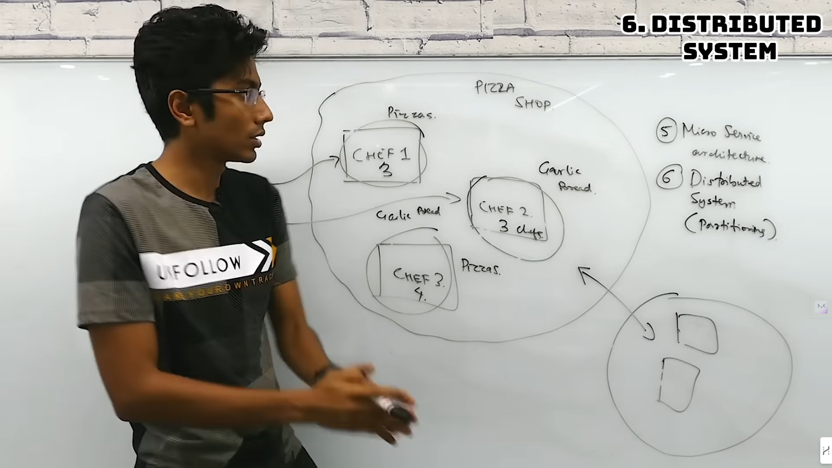

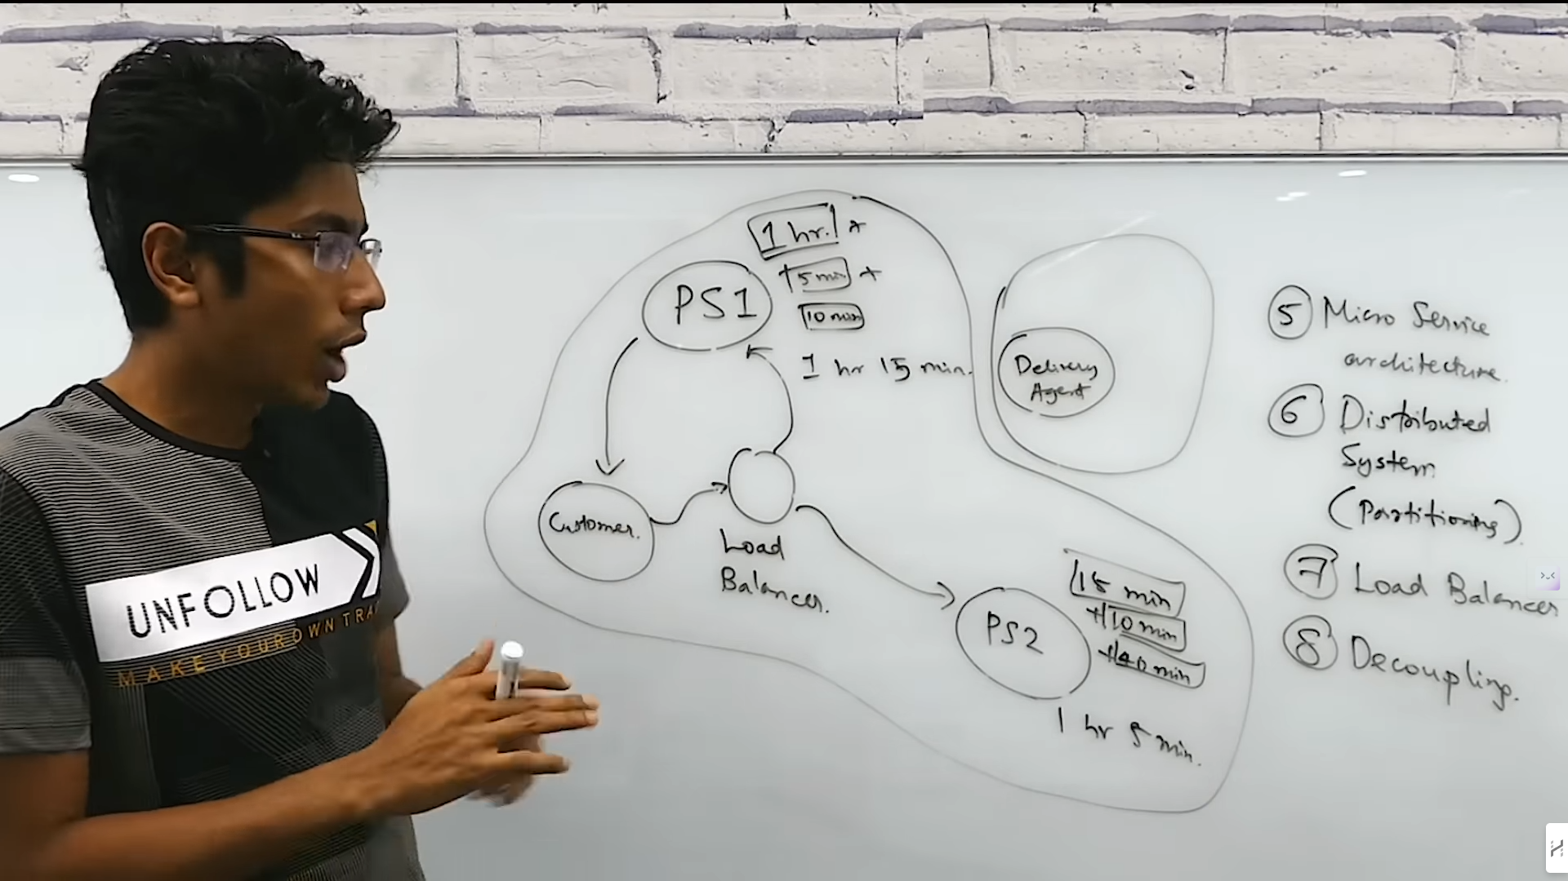



There are 2 Types of System Design : High Level Design and Low Level Design

High Level Design is all about the Deployment, scalability, extensible, fault Tolerance.

Low Level Design is how you write the Code actually.